PART I. (4.5ms)
Four answer choices are given below each sentence. Select the best answer to complete the sentence. Then mark the letter of your choice (A), (B), (C), or (D) on your ANSWER SHEET.
1. Which of the following is NOT a peripheral, in computer terms? Answer 1 Câu hỏi 1 ABCD
A. Keyboard
B. Mouse
C. Monitor
D. Motherboard
2. Which can be both the input and output devices? Answer 2 Câu hỏi 1 ABCD
A. Touch screen monitor
B. Speaker
C. Printer
D. Scanner
3. Which of the following is NOT a networking device? Answer 3 Câu hỏi 1 ABCD
A. Gateway
B. Router
C. Compiler
D. Bridge
4. What is NOT the benefit of the Networking? Answer 4 Câu hỏi 1 ABCD
A. Sharing printers and other peripherals
B. Sharing an Internet connection
C. Sharing files across devices
D. Sharing software licenses
5. Which of the following can be software? Answer 5 Câu hỏi 1 ABCD
A. CAT-5 cable
B. Firewall
C. Floppy disk
D. Mainframe
6. Bluetooth is an example of ____. Answer 6 Câu hỏi 1 ABCD
A. Personal Area Network
B. Local Area Network
C. virtual private network
D. Metropolitan Area Network
7. Data communication system spanning states, countries, or the whole world is ____ and data communication system within a building or campus is ____. Answer 7 Câu hỏi 1 ABCD
A. LAN / WAN
B. WAN / LAN
C. LAN / MAN
D. WAN / MAN
8. ____ is a high-speed memory that is much faster than the main memory. Answer 8 Câu hỏi 1 ABCD
A. Internal
B. External
C. Cache
D. Primary
9. Data representation is based on the ____ number system, which uses two numbers to represent all data. Answer 9 Câu hỏi 1 ABCD
A. byte
B. binary
C. biometric
D. bicentennial
10. Which is not an internet protocol? Answer 10 Câu hỏi 1 ABCD
A. STP
B. IP
C. FTP
D. HTTP
11. Linux is a type of ____ software. Answer 11 Câu hỏi 1 ABCD
A. proprietary
B. open-source
C. commercial
D. shareware
12. Errors in a computer program are referred to as ____. Answer 12 Câu hỏi 1 ABCD
A. viruses
B. failures
C. crashes
D. bugs
13. All the programs inside the computer which make it usable are called ____. Answer 13 Câu hỏi 1 ABCD
A. system software
B. application software
C. shareware
D. firmware
14. A program designed to destroy data on your computer which can travel to infect other computers is called a/an ____. Answer 14 Câu hỏi 1 ABCD
A. virus
B. adware
C. spam
D. Trojan
15. A hacker contacts your phone or e-mails and attempts to acquire your password is called ____. Answer 15 Câu hỏi 1 ABCD
A. spamming
B. keylogging
C. spoofing
D. phishing
16. Which mail access protocol is used for sending emails across the internet? Answer 16 Câu hỏi 1 ABCD
A. POP3
B. MAPI
C. SMTP
D. IMAP
17. Which of the following is not a computer language? Answer 17 Câu hỏi 1 ABCD
A. BASIC
B. FORTRAN
C. C#
D. C+
18. Which of the following is used to read HTML code and to render Webpage? Answer 18 Câu hỏi 1 ABCD
A. Web Server
B. Web Matrix
C. Web Browser
D. Web network
19. ____ is a program that manages all the other application programs in a computer. Answer 19 Câu hỏi 1 ABCD
A. A utility program
B. An application program
C. A storage system
D. An operating system
20. Which hacker type works legally to help improve security? Answer 20 Câu hỏi 1 ABCD
A. Black Hat
B. White Hat
C. Yellow Hat
D. Grey Hat
21. What is the main role of a firewall? Answer 21 Câu hỏi 1 ABCD
A. To speed up the network
B. To connect different networks
C. To increase network capacity
D. To filter incoming and outgoing traffic
22. A program is a ____.Answer 22 Câu hỏi 1 ABCD
A. physical part of the computer
B. type of computer memory
C. set of instructions that performs a task
D. collection of hardware components
23. When you save data to ____, it will remain unchanged even when the computer is turned off. Answer 23 Câu hỏi 1 ABCD
A. primary storage device
B. secondary storage device
C. motherboard
D. Random Access Memory
24. ____ is a company that gives its customers access to the Internet, email addresses and data storage. Answer 24 Câu hỏi 1 ABCD
A. An Internet Service Provider
B. An Internet Protocol
C. Joint Photographic Experts Group
D. A Dynamic Host Configuration Protocol
25. Which of the following is not true about RAM? Answer 25 Câu hỏi 1 ABCD
A. RAM loses all data when the system shuts down
B. RAM works exactly like hard drive storage.
C. RAM is mainly used for short-term data access.
D. RAM is considered a volatile memory type.
26. What is the primary function of the BIOS in a computer system? Answer 26 Câu hỏi 1 ABCD
A. Managing system file operations
B. Connecting the system to the internet
C. Controlling display and graphic output
D. Starting hardware and loading the system
27. Which of the following best describes a domain name? Answer 27 Câu hỏi 1 ABCD
A. A physical address of a website stored on a server.
B. A protocol used for transferring files across the internet.
C. A unique string used to identify a website on the internet.
D. The IP address of a user's local computer.
28. A web cookie is a small piece of data ____.Answer 28 Câu hỏi 1 ABCD
A. sent by the client to the server to manage internet traffic
B. sent by the server to the client and saved in the browser
C. designed to scan the computer system for possible viruses
D. sent from a root server to update information for all servers
29. What is multiprocessing in an operating system? Answer 29 Câu hỏi 1 ABCD
A. Running multiple programs on a single processor
B. Running a single program on multiple processors
C. Running multiple programs on multiple processors
D. None of the above
30. In the context of software, what does the term "open source" mean? Answer 30 Câu hỏi 1 ABCD
A. Software that can be freely modified and redistributed
B. Software exclusive to a particular operating system
C. Software with a closed user interface
D. Software designed for secure data storage

PART II.
Match the definitions with corresponding terms. There are some extra terms. Write your answers on the answer sheet.
1. A computer that provides data/resources to others.
Answer Server
2. A high-performance computer used by professionals.
Answer 2 Workstation
3. A quick way to perform a function or open a program.
Answer 3 Shortcut
4. A portable device with a touch interface.
Answer 4 Tablet
5. A visual interface using icons and menus.
Answer 5 Graphical User Interface
6. A device used to enter data.
Answer 6 Input Device
7. A part that completes tasks for the computer.
Answer Processor
8. An electrical device that supplies electricity to computer components.
Answer Power Supply
9. A circuit board that adds functions to a computer.
Answer Expansion Card
10. A kind of software that manages hardware and runs applications.

Operating System

A. Workstation
B. Server
C. Tablet
D. Processor
E. Expansion Card
F. Power Supply
G. Scroll Wheel
H. Input Device
I. Touch Screen
J. Graphical User Interface
K. Shortcut
L. Operating System

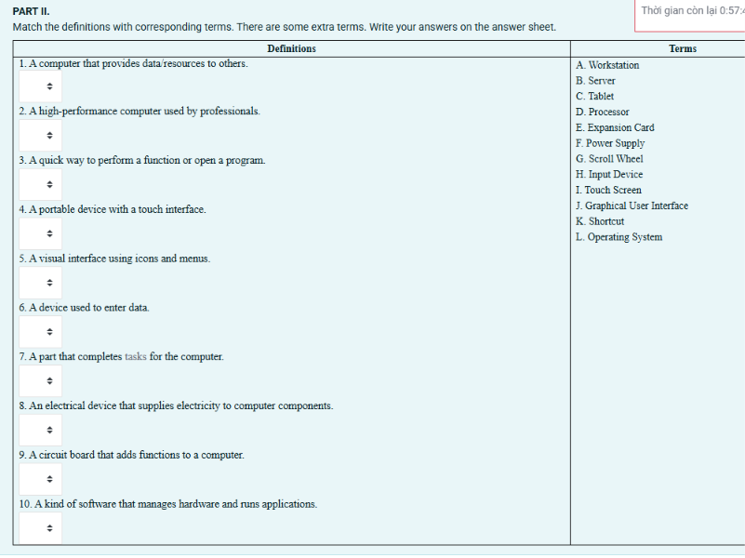
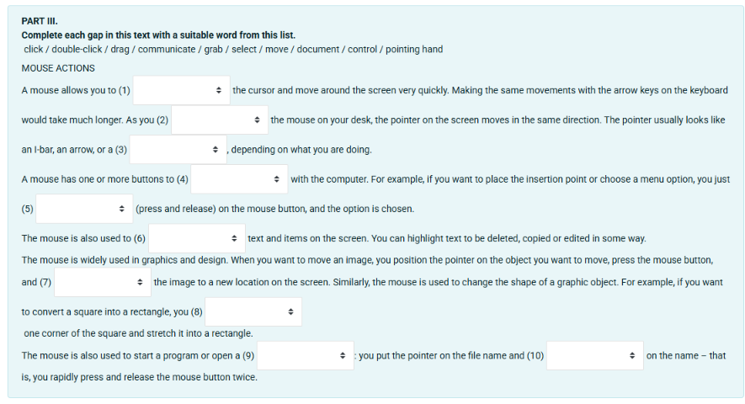
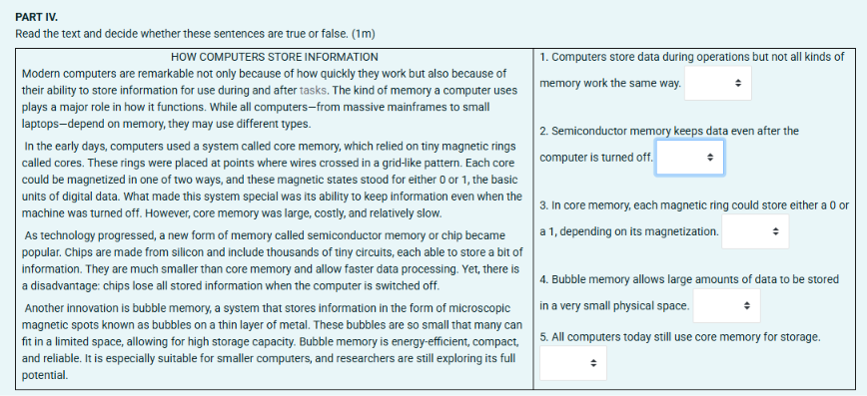
TRUE / FALSE
